Create S3 Object lock with retention mode as Governance

Lab Steps

Task 1: Sign in to AWS Management Console
- Click on the Open Console button, and you will get redirected to AWS Console in a new browser tab.
- On the AWS sign-in page,
  - Leave the Account ID as default. Never edit/remove the 12 digit Account ID present in the AWS Console. otherwise, you cannot proceed with the lab.
  - Now copy your User Name and Password in the Lab Console to the IAM Username and Password in AWS Console and click on the Sign in button.
- Once Signed In to the AWS Management Console, Make the default AWS Region as US East (N. Virginia) us-east-1.

Task 2: Creating a Bucket
- Navigate to the Services menu at the top. Click on S3 in the Storage section.
- In the S3 dashboard, click on the Create Bucket button and fill in the bucket details.
- In the General Configuration,
- Bucket type : General Purpose
- Bucket name: Enter whizdemo123
- Note: S3 Bucket names are globally unique, choose a name that is available. Maybe you can enter your name and create one.
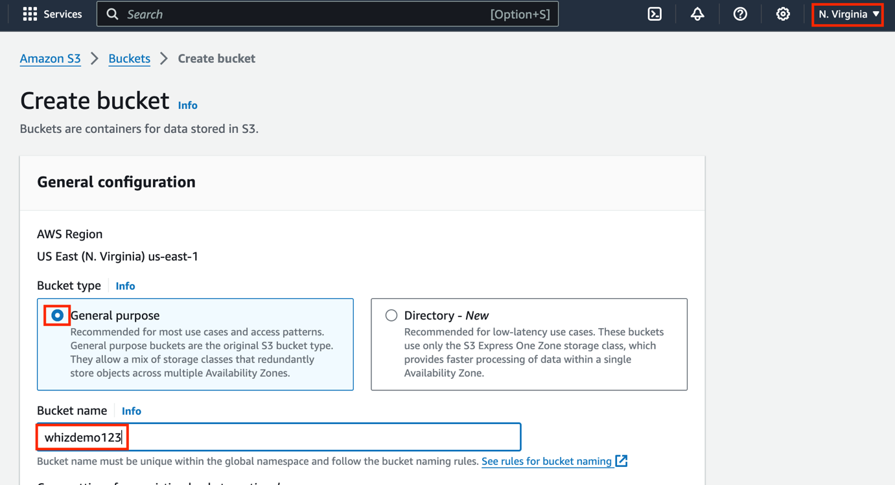
- Object ownership: Select ACLs disabled (recommended) option
- Block Public Access settings for this bucket: default
- Bucket versioning: Enable
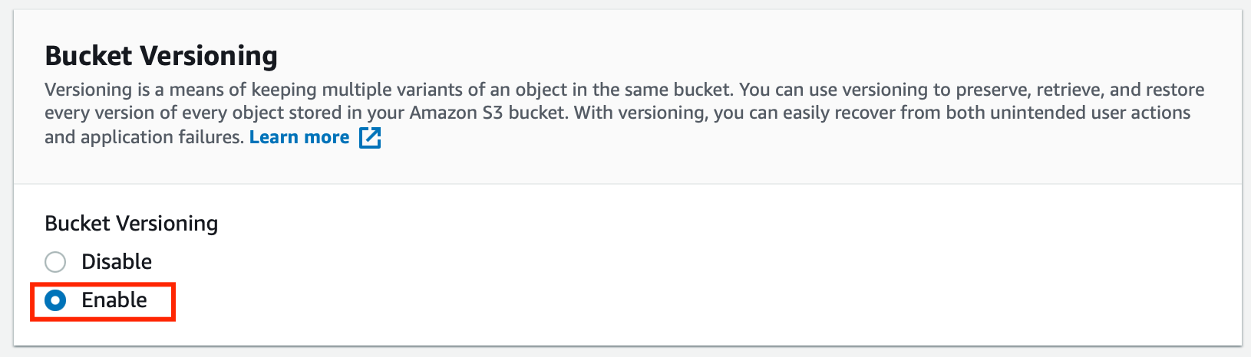
- Tags: Keep it default
- Default encryption: Disable
- Click on the Advanced settings to see the options
- Object Lock: Enable
- Acknowledge the Object lock by checking the option.
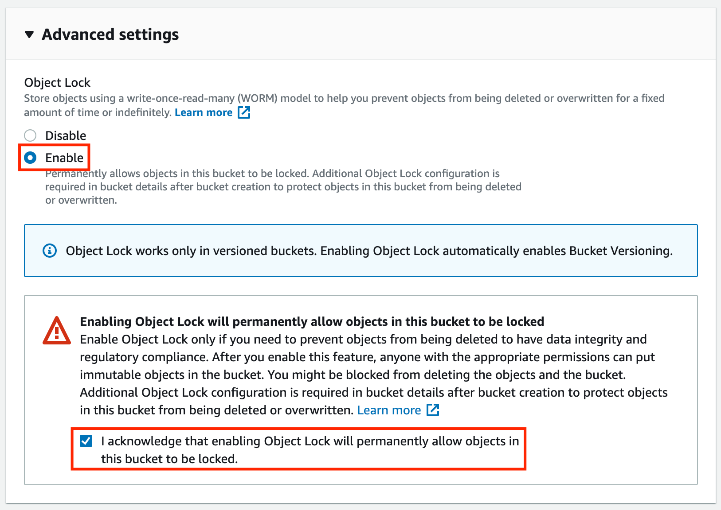
- Click on Create Bucket button.

Task 3: Uploading Object to the Bucket
- Click on your bucket name.
- In the Overview, You can see the following message
  - You don't have any objects in this bucket.
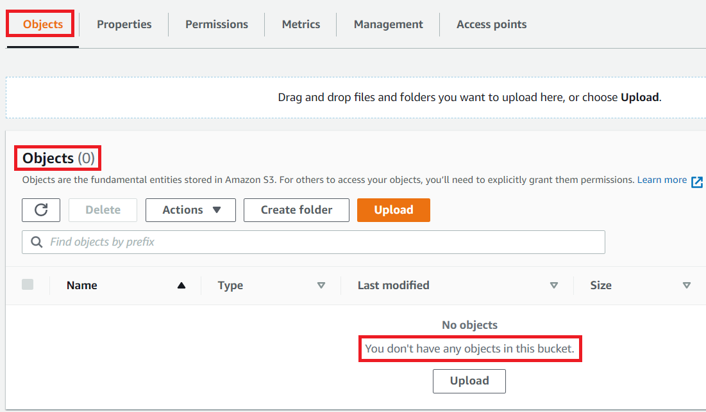
- You can upload any image from your local machine or you can download our test image from Download Me.
- To upload a file to our S3 bucket,
  - Click on Upload button.
  - Click on Add files button.
  - Browse for your local image or the image we provided and select it.
  - Click on the Upload button.
- You can watch the progress of the upload from within the transfer panel at the bottom of the screen.
- Once your file has been uploaded, it will be displayed in the bucket.
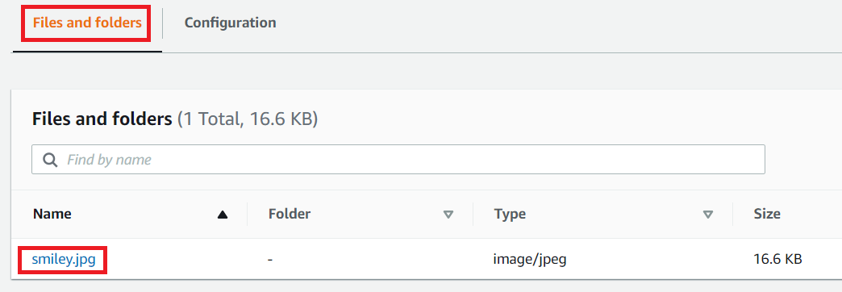
- Now click on the Exit button on the top right corner of the screen.

Task 4: Enable retention period for the object uploaded
- Click on the Object present i.e. smiley.jpeg
- Scroll to the end of this page and you will see the option of Object Lock retention.
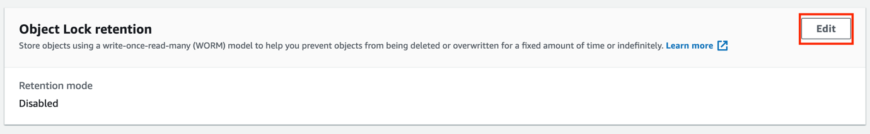
- Click on the Edit button.
- For the Object Lock retention setting, use the following setting:
- Retention: Enable
- Retention mode: Governance
- Retain until date: Select tomorrow date
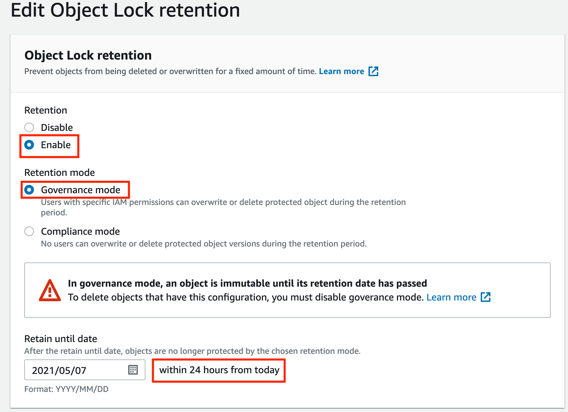
- Click on the Save changes button.

Task 5: Test the object lock feature by deleting the file
- Go back to the page where all the objects present in the bucket are listed.
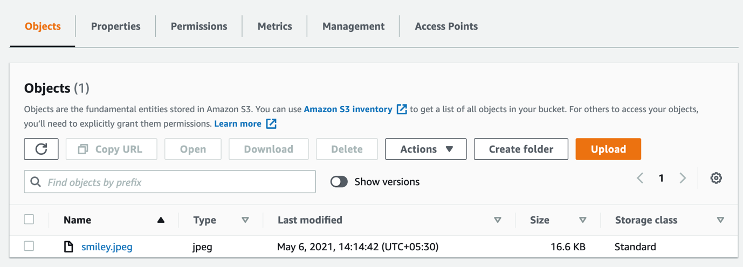
- Click on the toggle to show the versions of the objects present.
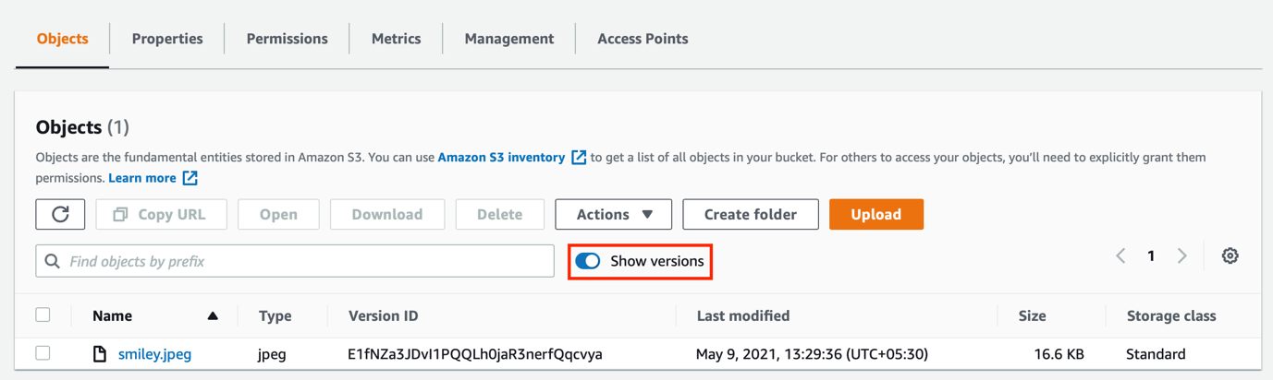
- To delete the object, select the file and click on the Delete button.
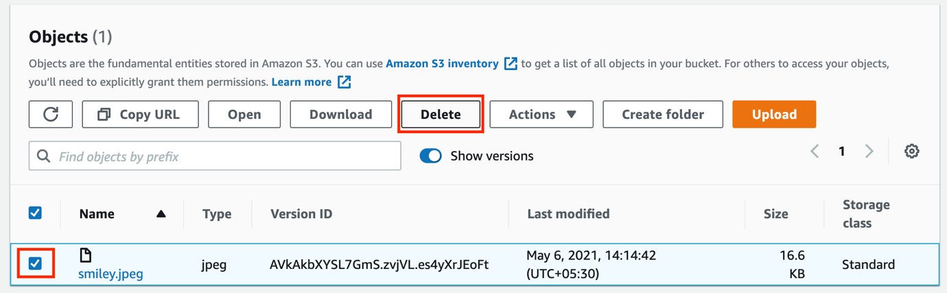
- To confirm the deletion, type the permanently delete keyword in the text box provided and click on the Delete objects button.
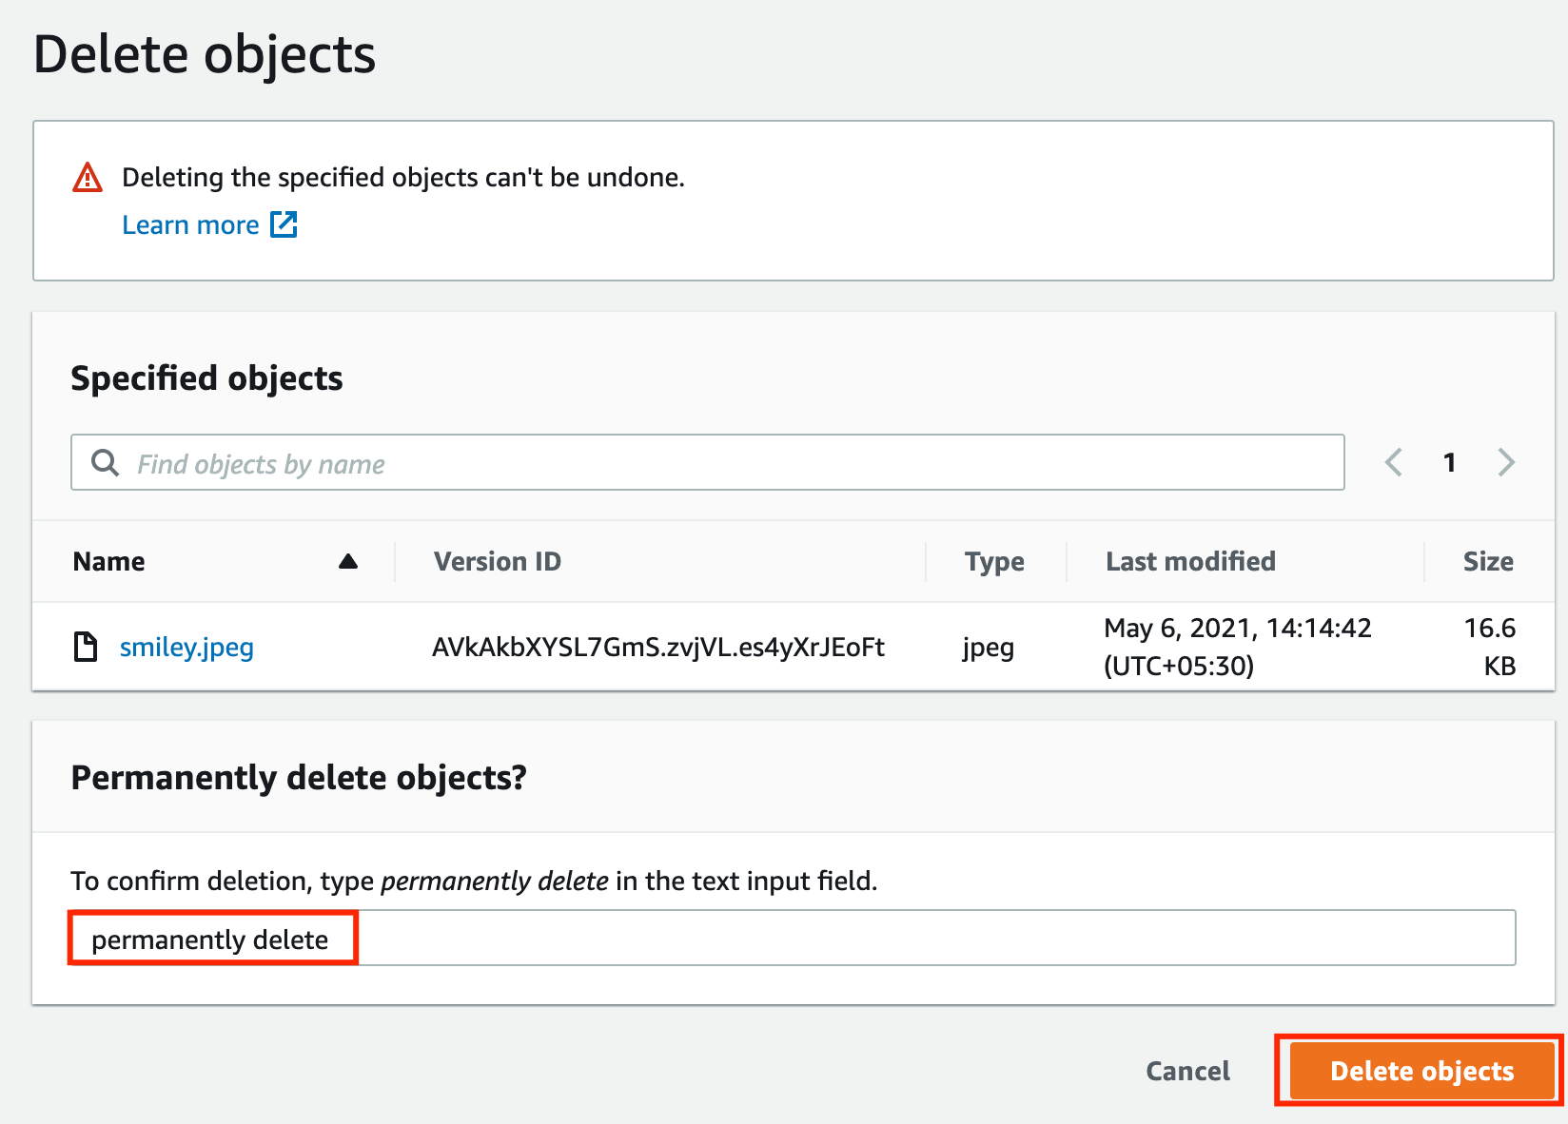
Note: If you are trying to delete a version, it will be shown as deleted. But it adds a delete marker. To delete the object make sure the toggle the versions, select the file, and then delete.
- And deletion will fail. Because the file has a retention period of 1 day.
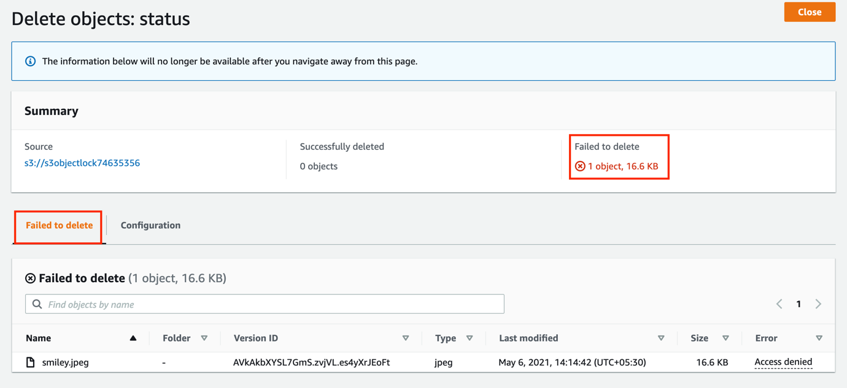

Do You Know ?
You can use S3 Object Lock retention governance mode to protect objects against being overwritten or deleted for up to 100 years.

